Created a **Virtual AI Agent** on **N8N Tool** for Collecting Data of Instagram **Influencers data from Instagram…**

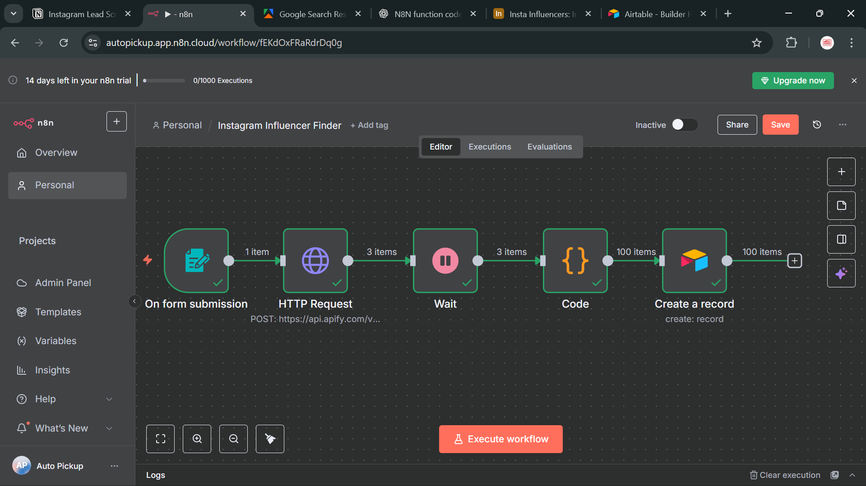

Attached this module for **Web Surfing** and Searching our results…

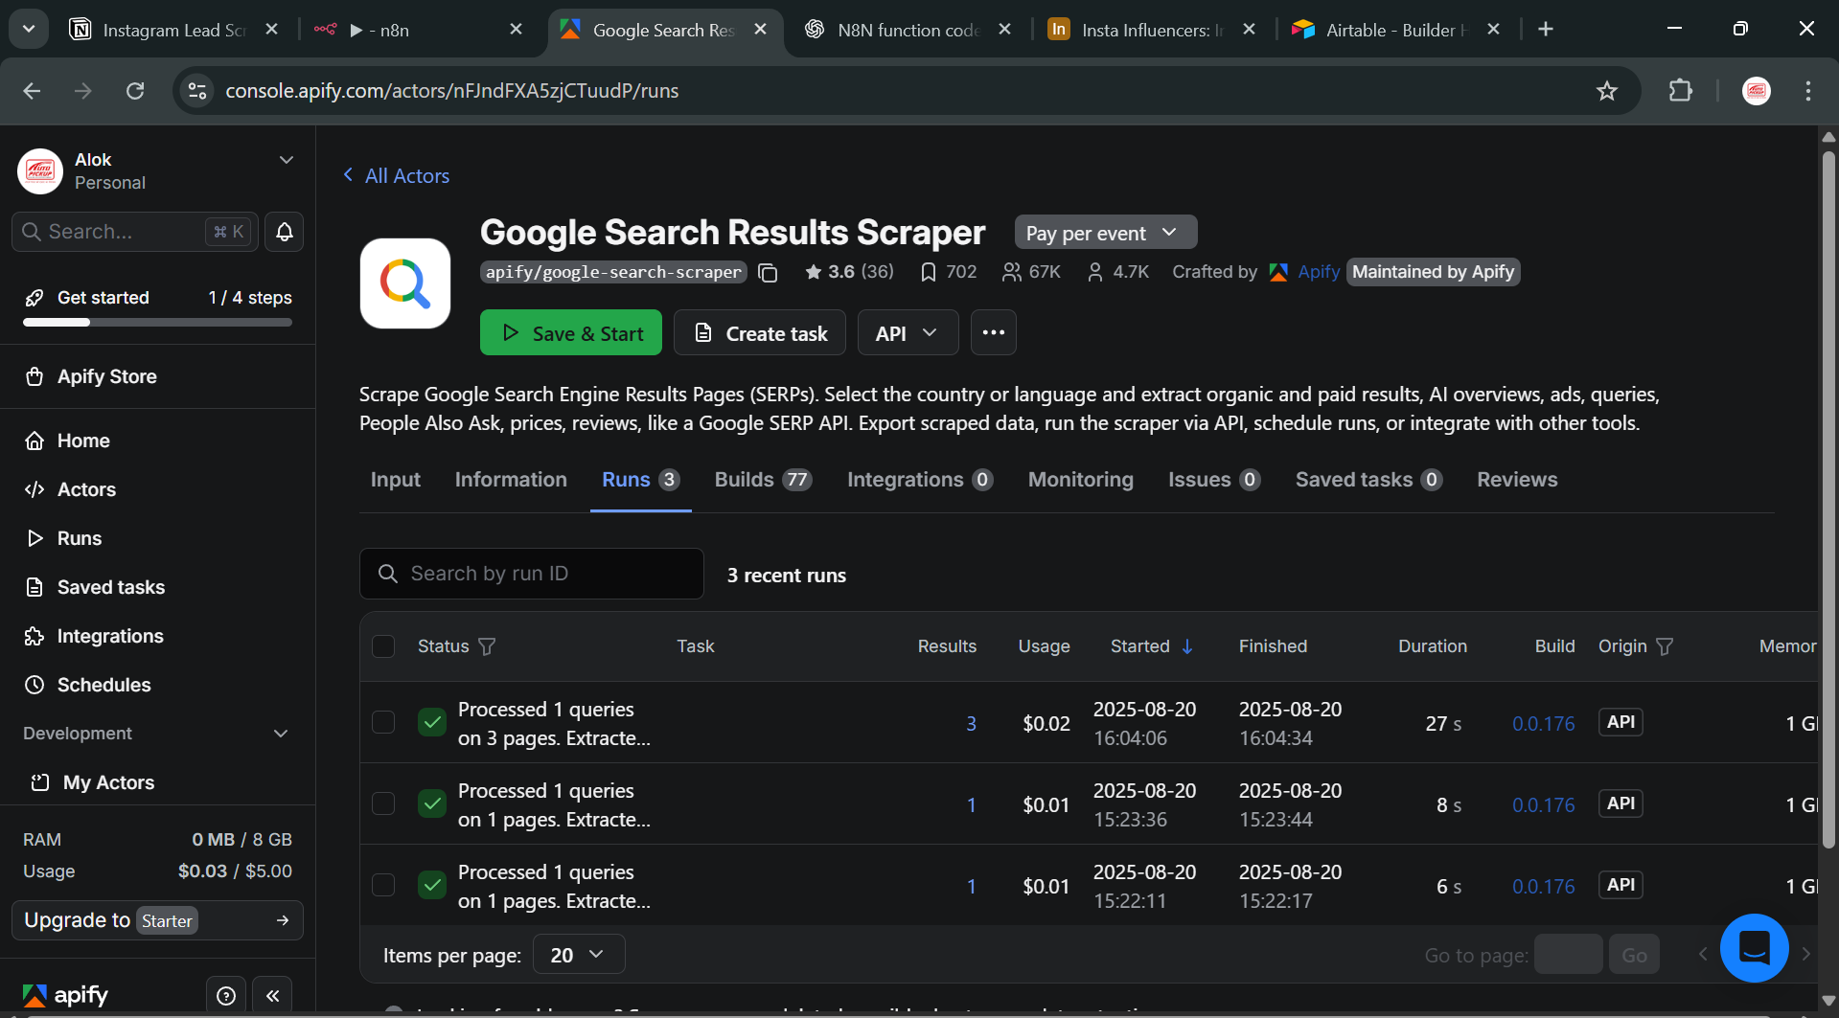

Connected **Apify Database** for Data Collection and Collected data on Apify Database…

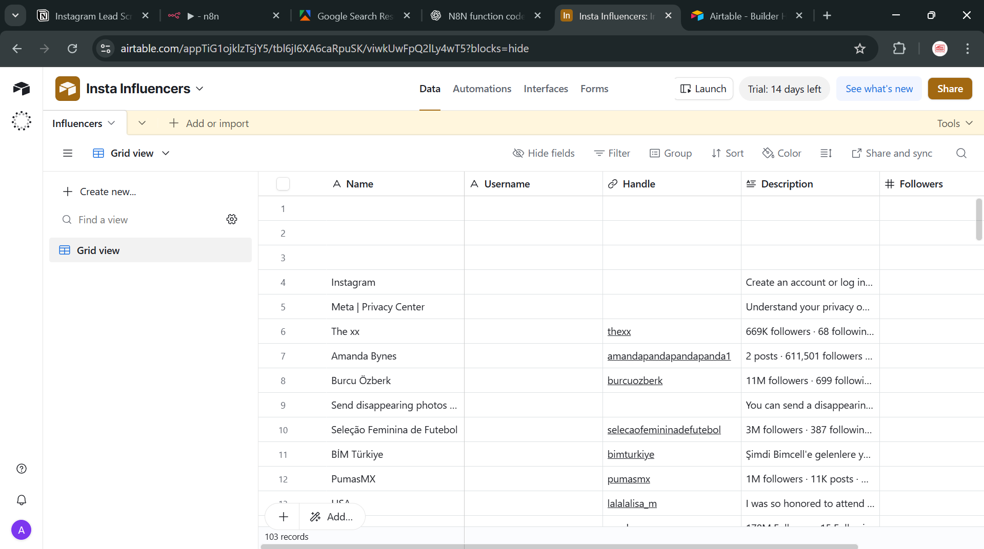

**Workflow Links of Projects :-**

**N8N :-** [**https://autopickup.app.n8n.cloud/workflow/fEKdOxFRaRdrDq0g**](https://autopickup.app.n8n.cloud/workflow/fEKdOxFRaRdrDq0g)

**Apify Google search Scrapper :-** [**https://console.apify.com/actors/nFJndFXA5zjCTuudP/runs**](https://console.apify.com/actors/nFJndFXA5zjCTuudP/runs)

**AitTable Database Link :- [https://airtable.com/appTiG1ojklzTsjY5/tbl6jI6XA6caRpuSK/viwkUwFpQ2lLy4wT5?blocks=hide\](https://airtable.com/appTiG1ojklzTsjY5/tbl6jI6XA6caRpuSK/viwkUwFpQ2lLy4wT5?blocks=hide\\)**